**Labwork 5**

Muhammad Aldy Faturrohman  
K3521050

**Latihan 1:**

#layera{

position: absolute;

margin: 20px 150px;

height: 200px;

width: 200px;

background: yellow;

z-index: 3;

}

#layerb{

position: absolute;

margin: 100px 0;

height: 150px;

width: 300px;

background: lightblue;

z-index: 2;

}

#layerc{

position: absolute;

margin: 0 20px;

height: 200px;

width: 400px;

background: red;

z-index: 1;

}

**Latihan 2:**

Latihan2.html:

<div class="menu">

<a href="#">HOME</a>

<a href="#">PROFILE</a>

<a href="#">ACADEMIC</a>

<a href="#">ABOUT</a>

<a href="#">PORTOFOLIO</a>

</div>

Style.css

.menu{

background-color: darkcyan;

margin: 0px;

overflow: hidden;

z-index: 1;

position: sticky;

top: 0px;

}

.menu a{

text-decoration: none;

display: inline-block;

color: white;

text-align: center;

padding: 20px 24px;

font-size: 18px;

}

.menu a:hover{

background: teal;

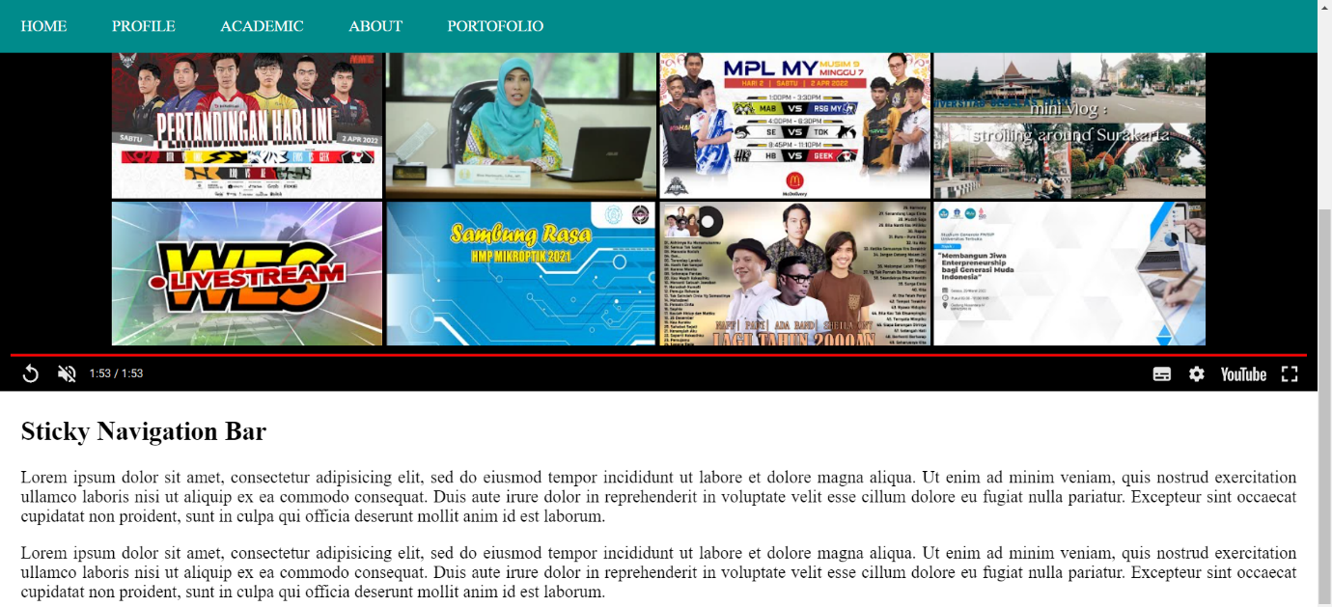

**Latihan 3:**

Latihan3.html

<!DOCTYPE html>

<html>

<head>

<link rel="stylesheet" type="text/css" href="stylelatihan3.css">

<title>Desain Web</title>

</head>

<body>

<div id="wrap">

<div id="kiri">

<br><center>

<img src="images/logo.png" height="200" width="200">

</center><br>

<h2>Artikel Populer</h2>

<ul>

<li><a href="#">Desain Web</a></li>

<li><a href="#">HTML</a></li>

<li><a href="#">CSS</a></li>

<li><a href="#">Lain-lain</a></li>

</ul>

</div>

<div id="header">

<div id="judul">

<a href="#">Belajar Layout Website</a>

</div>

<div class="desc">

Menggunakan HTML dan CSS

</div>

</div>

<div id="menu">

<ul>

<li><a href="#">HOME</a></li>

<li><a href="#">TENTANG</a></li>

<li><a href="#">GALERI</a>

<ul>

<li><a href="#">VIDEO</a></li>

<li><a href="#">PHOTO</a>

<ul>

<li><a href="#">PRIBADI</a></li>

<li><a href="#">UMUM</a></li>

</ul>

</li>

</ul>

</li>

<li><a href="#">KONTAK</a></li>

<li><a href="#">DAFTAR</a></li>

<li><a href="#">BUKU TAMU</a></li>

</ul>

</div>

<div id="konten">

<div class="posttittle">Selamat Datang</div>

<div class="post">

<p>

Belajar Membuat Layout Desain Web menggunakan HTML dan CSS dengan mudah.

</p>

<p>

Untuk belajar HTML klik halaman <b><a href="#">HTML</a></b> dan belajar CSS ke halaman <b><a href="#">CSS</a></b>.

</p>

</div>

<div class="posttittle">Galeri</div>

<div class="post">

<img src="images/konten.png">

</div>

</div>

<div id="footer">

&copy Copyright 2020. All Right Reserved <br> Prodi Pendidikan Teknik Informatika dan Komputer <br> Universitas Sebelas Maret

</div>

</div>

</body>

</html>

Stylelatihan3.css

#wrap{

width: 1000px;

height: 800px;

margin: 0 auto;

background-color: #ecdf52;

}

#header{

background-image: url(images/header.jpg);

border-bottom-right-radius: 50px;

width: 730px;

height: 300px;

margin: auto;

box-shadow: 0 0 10px rgba(0, 0, 0,.25);

float: right;

}

#judul{

font-size: 50px;

text-align: right;

padding: 200px 40px 0 0;

}

#judul a{

color: white;

text-decoration: none;

}

#judul a:hover{

color: gray;

}

.desc{

font-size: 30px;

color: white;

text-align: right;

padding: 0 40px 0 0;

}

#menu ul{

float: right;

background: #0457A0;

padding: 0 0px;

position: relative;

box-shadow: 0 0 10px rgba(0, 0, 0,0.25);

list-style: none;

width: 730px;

}

#menu ul:after{

content: "";

clear: both;

display: block;

}

#menu ul li{

float: left;

}

#menu ul li:hover{

background: #26B9C8;

}

#menu ul li a{

display: block;

color: white;

padding: 10px 20px;

text-decoration: none;

}

#menu ul li:hover a{

color: white;

}

#menu ul li:hover > ul {

display: block;

}

#menu ul ul{

background: #0457A0;

position: absolute;

padding: 0;

top: 100%;

display: none;

width: auto;

}

#menu ul ul li{

float: none;

position: relative;

}

#menu ul ul li a{

padding: 10px 30px;

color: white;

}

#menu ul ul li a:hover{

background: #26B9C8;

color: white;

}

#menu ul ul ul{

position: absolute;

left: 100%;

top: 0;

}

#kiri{

border-top-left-radius: 50px;

background-color: #fbeb05;

width: 250px;

height: auto;

margin: 0 0 20px;

float: left;

list-style: none;

box-shadow: 0 0 10px rgba(0, 0, 0,.25);

}

#kiri ul{

margin: 0 0 20px 20px;

padding: 0;

list-style: none;

width: 200px;

}

#kiri li{

width: 100%;

margin: 0;

padding: 0;

list-style: none;

}

#kiri h2{

margin: 0px 0 0px 0;

padding: 5px 12px;

color: white;

font-size: 20px;

background: #0457A0;

}

#kiri a{

display: block;

padding: 3px 10px;

text-decoration: none;

color: black;

border-bottom: 1px dotted blue;

}

#kiri a:hover{

background: #26B9C8;

color: white;

}

#konten{

background-color: #fbeb05;

width: 690px;

height: auto;

margin: 0 0 20px;

padding: 20px;

float: right;

box-shadow: 0 0 10px rgba(0, 0, 0,.25);

}

.posttittle{

text-decoration: none;

font-size: 30px;

font-family: Arial;

color: #0457A0;

}

.postittle a{

text-decoration: none;

}

.post{

margin: 0 20px 0 20px;

text-align: justify;

}

b a{

color: #0457A0;

text-decoration: none;

}

img{

width: 40%%;

}

#logo{

width: 200px;

height: 200px;

}

#footer{

background-color: #fbeb05;

padding: 20px 0 0 0;

width: 1000px;

height: 90px;

clear: both;

margin: 20 0;

text-align: center;

color: black;

border-top-left-radius: 50px;

border-bottom-right-radius: 50px;

}

